**SCHOOL OF COMPUTER SCIENCE**

**UNIVERSITY OF PETROLEUM AND ENERGY STUDIES**

**DEHRADUN, UTTARAKHAND**



**COMPUTER GRAPHICS**

**LABORATORY FILE**

**(2024-2025)**

**For**

**Vth Semester**

**Submitted To: Submitted By:**

Mr. Dinesh Akshat Negi

Assistant Professor 500106533(SAP ID)

[Vth Semester] R2142220414(Roll No.)

School of Computer Science B.Tech. CSF (Batch-1)

**LAB EXPERIMENT – 3**

**Drawing a Circle and an Ellipse**

**[Usage of Open GL]**

***# Take the value of radius, major axis and minor axis as input from the user.***

1. **Draw the circle with the help of polar equations**

#include <GL/freeglut.h>

#include <iostream>

#include <cmath>

#include <math.h>

# define M_PI 3.14159265358979323846 /* pi */

using namespace std;

int radius = 100;

int centerX = 320;

int centerY = 240;

void init() {

glClearColor(1.0, 1.0, 1.0, 1.0);

gluOrtho2D(0, 640, 0, 480);

}

void drawCirclePolarEquation() {

glBegin(GL_LINE_LOOP);

for (double angle = 0; angle <= 360; angle += 1) {

double x = centerX + radius * cos(angle * M_PI / 180);

double y = centerY + radius * sin(angle * M_PI / 180);

glVertex2i(x, y);

}

glEnd();

}

void display() {

glClear(GL_COLOR_BUFFER_BIT);

glColor3f(0.0, 0.0, 0.0);

// Draw the circle using polar equations

drawCirclePolarEquation();

glFlush();

}

int main(int argc, char** argv) {

glutInit(&argc, argv);

glutInitDisplayMode(GLUT_SINGLE | GLUT_RGB);

glutInitWindowSize(640, 480);

glutInitWindowPosition(100, 100);

glutCreateWindow("Circle Drawing Using Polar Equations --> Akshat Negi");

init();

glutDisplayFunc(display);

glutMainLoop();

return 0;

}

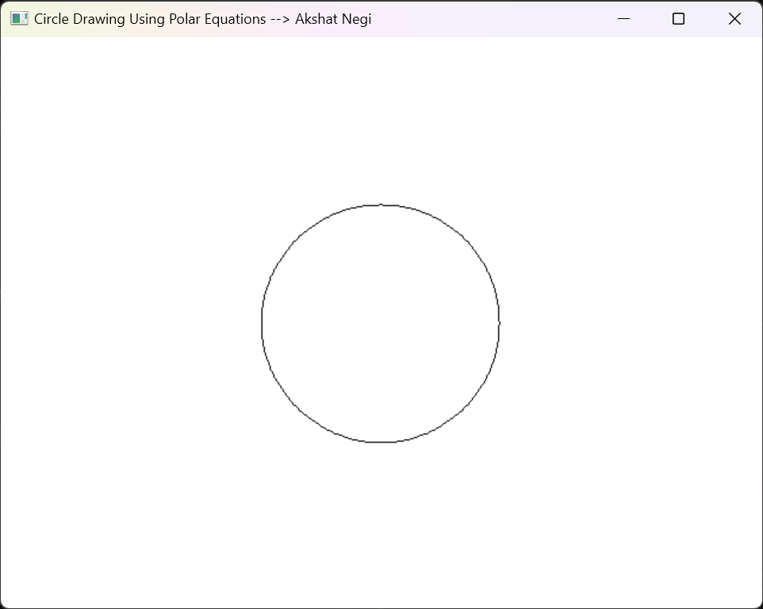

1. **Draw the circle with the help of mid-point method.**

#include <iostream>

#include<math.h>

#include<GL/freeglut.h>

using namespace std;

void circle() {

glColor3f(0.0, 0.0, 0.0);

glPointSize(2.0);

float r = 100;

float x = 0, y = r;

float p = 1 - r;

glBegin(GL_POINTS);

while (x != y)

{

x++;

if (p < 0) {

p += 2 * (x + 1) + 1;

}

else {

y--;

p += 2 * (x + 1) + 1 - 2 * (y - 1);

}

glVertex2i(x, y);

glVertex2i(-x, y);

glVertex2i(x, -y);

glVertex2i(-x, -y);

glVertex2i(y, x);

glVertex2i(-y, x);

glVertex2i(y, -x);

glVertex2i(-y, -x);

}

glEnd();

glFlush();

}

int main(int argc, char** argv) {

glutInit(&argc, argv);

glutInitDisplayMode(GLUT_SINGLE | GLUT_RGB);

glutInitWindowSize(500, 500);

glutInitWindowPosition(100, 100);

glutCreateWindow("Circle using midpoint --> Akshat Negi");

glClearColor(1.0, 1.0, 1.0, 1.0);

glClear(GL_COLOR_BUFFER_BIT);

gluOrtho2D(-250, 250, -250, 250);

glMatrixMode(GL_PROJECTION);

glViewport(0, 0, 500, 500);

glutDisplayFunc(circle);

glutMainLoop();

return 0;

}

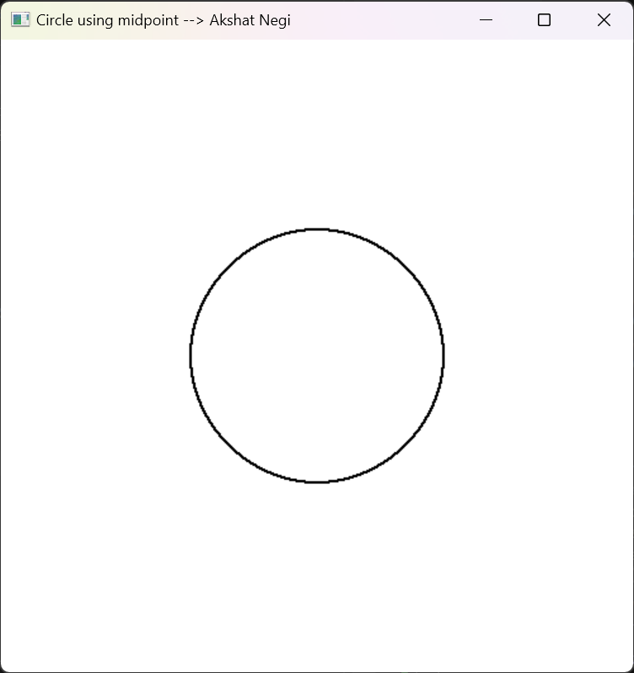

1. **Draw the Ellipse with the mid-point method.**

#include <GL/freeglut.h>

#include <iostream>

using namespace std;

int rx, ry;

int xi, yi;

void ellipseMidPoint() {

int x = 0, y = ry;

int p1 = (ry * ry) + (rx * rx * 0.25) - (ry * rx * rx);

int dx = 2 * x * (ry * ry);

int dy = 2 * y * (rx * rx);

while (dy > dx) {

glVertex2i(x + xi, y + yi);

glVertex2i(x + xi, -y + yi);

glVertex2i(-x + xi, -y + yi);

glVertex2i(-x + xi, y + yi);

if (p1 < 0) {

x++;

dx = 2 * x * (ry * ry);

p1 += dx + (ry * ry);

}

else {

x++;

y--;

dx = 2 * x * (ry * ry);

dy = 2 * y * (rx * rx);

p1 += dx + (ry * ry) - dy;

}

}

int p2 = (ry * ry * (x + 0.5) * (x + 0.5)) + (rx * rx * (y - 1) * (y - 1)) - (rx * rx * ry * ry);

while (y > 0) {

glVertex2i(x + xi, y + yi);

glVertex2i(x + xi, -y + yi);

glVertex2i(-x + xi, -y + yi);

glVertex2i(-x + xi, y + yi);

if (p2 > 0) {

y--;

dy = 2 * y * (rx * rx);

p2 += (rx * rx) - dy;

}

else {

y--;

x++;

dy -= 2 * (rx * rx);

dx += 2 * (ry * ry);

p2 += dx + (rx * rx) - dy;

}

}

}

void display() {

//glClear(GL_COLOR_BUFFER_BIT); already mentioned in main program

glColor3f(0.0, 1.0, 1.0);

glPointSize(5.0);

glBegin(GL_POINTS);

//int rx = 40, ry = 50, xi = 200, yi = 250;

ellipseMidPoint();

glEnd();

glFlush();

}

int main(int argc, char** argv)

{

cout << "\n\nEnter Center Of Ellipse \n\n";

cout << "\n x = ";

cin >> xi;

cout << "\n y = ";

cin >> yi;

cout << " Enter a Semi Major Axix : ";

cin >> rx;

cout << " \nEnter a Semi Minor Axis: ";

cin >> ry;

glutInit(&argc, argv);

glutInitDisplayMode(GLUT_SINGLE | GLUT_RGB);

glutInitWindowSize(500, 500);

glutInitWindowPosition(100, 100);

glutCreateWindow("Drawing Algorithm --> Akshat Negi");

glClearColor(0.0, 0.0, 0.0, 1.0);

glClear(GL_COLOR_BUFFER_BIT);

gluOrtho2D(0, 500, 0, 500);

glMatrixMode(GL_PROJECTION);

glViewport(0, 0, 500, 500);

glutDisplayFunc(display);

glutMainLoop();

return 0;

}

